Name: ____________________________________________________ Period: _______ Date: _________________

Latin America Country Report Extension Questions – Teacher Model

Directions: After completing your Latin America Country Report, here are 3 extension questions that you should answer.
- #1 & #2 are required. #3 is optional (Extra Credit).
- You must cite at least one source (other than Wikipedia) for #1 & #2.

#1 What is one major issue (socially, politically, or economically) that this country is dealing with right now? Please identify the issue and explain what it means.

Mexico is currently struggling to control the production, use, and sale of illegal drugs. This has affected the stability and growth of the country and caused issues well past its borders. Illegal drug trafficking became a major issue in the 1960s and has only increased since that time. Due to its central location to the US, Central America, and South America, many drug handlers around the world go through Mexico in hopes of maximizing their profits. Mexico’s historically weak local legal infrastructure and relative lack of educational opportunities for many of its youth have also contributed to its drug problem. Criminals in Mexico have been able to make a significant amount of illegal money regularly shipping cocaine, marijuana, heroin, and methamphetamine not only within Mexico but to neighboring countries as well. For example, it is estimated that Mexican drug cartels (illegal organizations) take in between $19 and $29 billion per year from U.S. drug sales.
In 2006, newly elected Mexican president Felipe Calderon deployed over 6,500 of his country’s soldiers in an effort to battle the illegal drug trade. Despite these efforts, there have been over 60,000 people killed related to the illegal drug trade since he took office. These deaths include drug dealers but also federal authorities, military personnel and innocent civilians as casualties.

Sources:
http://geo-mexico.com/wp-content/uploads/2010/04/STRATFOR-Mexican-drug-cartels-map.jpg

http://www.cnn.com/2013/09/02/world/americas/mexico-drug-war-fast-facts/

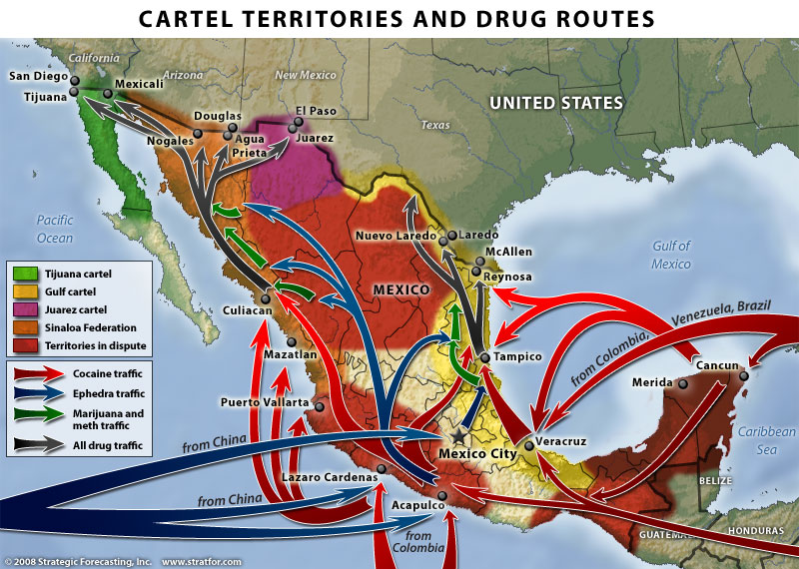
#2 Has any recent progress been made on this issue? Please explain using specific examples.

Although it is still a significant problem, there have been signs in recent years that progress is being made on reducing the drug trade. In July 2013, two leaders of Mexican drug cartels were captured and detained by officials. Teodoro “El Teo” Garcia, who was the leader of the Arellano Felix drug cartel, was captured by a joint task force while hiding out in La Paz, an area of Baja, California. Around the same time, Mexican Marines captured Miguel Angel Trevino Morales, who was the leader of the Zeta drug cartel (Los Zetas). Both men were known for their extreme brutality and violence. Prior to 2008, the majority of violence in Mexico took place between members of rival cartels. But Garcia took a more vicious approach when he came into power, often capturing innocent citizens, holding them for ransom, and killing those who refused to pay or cooperate with their demands. There were many accounts of gruesome deaths at the hands of these men and their organizations. Their capture will hopefully be a sign of a positive change of the tides and continued reduction of the crime and violence that has become so prevalent in many parts of Mexico.

Another sign of progress against the drug trade was reported just last week (January 16, 2014) when the U.S. border patrol unleashed a fleet of extremely mobile, tiny-sized robots to explore the growing number of drug tunnels between the U.S. – Mexico border. These small robots are only 19 inches wide and can flip, travel through rough terrain, and climb stairs. The robots are equipped with cameras so they can warn agents navigating these dark passageways of any potential danger ahead of them.

By continuing to minimize the profit made from participating in the drug trade, officials hope to disincentivize criminals and weaken the cartels that are dependent on the illegal activity.

Sources:
http://www.csmonitor.com/USA/2014/0116/Tiny-robots-to-prowl-US-Mexico-border-s-dark-drug-tunnels

http://www.nytimes.com/2013/07/17/world/americas/capture-of-mexican-crime-boss-appears-to-end-a-brutal-chapter.html?ref=drugtrafficking

http://articles.latimes.com/2013/jul/20/local/la-me-cartel-manhunt-20130721

#3 How do you think things will look with regards to this issue 10 years from now? Why?

Like many problems that have developed over time, ten years many not be long enough to address all the problems that plague the country because of the drug trade. As long as criminals are still earning significantly more in the drug trade than participating in the legal work force, they may choose to continue on that path rather than turn themselves in to authorities. Still, I am optimistic that it will be less of a factor due to the stated desire and past efforts of Mexico’s last president and the current president, Enrique Pena Nieto who began his six-year term as president in December 2012. It is up to Mexico to make sure that they create an environment that is supportive of an increased labor force by creating educational opportunities and incentives for businesses to invest so that citizens can see the potential and benefits of participating in the legal job market.

