1. According to the title, how did America feel about expanding its territory?

2. What is propaganda? Is this an example of propaganda? Explain.

3. Describe the painting. Be sure to include a description of the figures, the use of light, and the changing landscape.

4. What attitudes about the European American movement westward does this painting project? In what specific details?

5. If you were thinking about moving westward in 1872, how would this painting make you feel?

6. If you were to make a painting about Manifest Destiny from the Native American point of view, what would it depict?

Artist: John Gast
American Progress, 1872
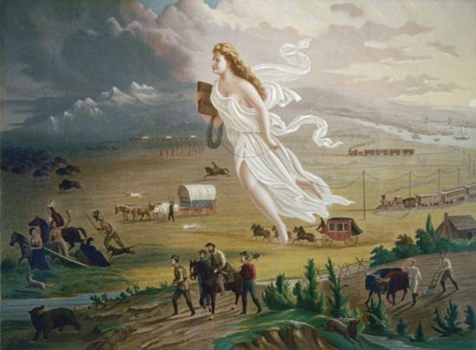

Manifest Destiny: depiction in chromolithograph print, c. 1873. Photograph. Encyclopædia Britannica Online School Edition. Web. 14 Jan. 2011. <http://school.eb.com/eb/art-113284>.

If you would like to see the image in color, go the Databases – Britannica Online Image Quest –
search “American Progress”

