Document A: The Reconstruction Amendments (Modified)

The 13th, 14th and 15th amendments to the United States Constitution are sometimes called the “Reconstruction Amendments.” They were passed inorder to abolish slavery and to establish the rights of former slaves.

13th Amendment: 1865
Section 1. Neither slavery nor involuntary servitude, except as a punishment for crime whereof the party shall have been duly convicted, shall exist within the United States, or any place subject to their jurisdiction.

14th Amendment: 1868
Section 1. All persons born or naturalized in the United States . . . are citizens of the United States and of the State wherein they reside. No State shall make or enforce any law which shall abridge the privileges or immunities of citizens of the United States; nor shall any State deprive any person of life, liberty, or property, without due process of law; nor deny to any person within its jurisdiction the equal protection of the laws.

15th Amendment: 1870
Section 1. The right of citizens of the United States to vote shall not be denied or abridged by the United States or by any State on account of race, color, or previous condition of servitude.

Vocabulary
jurisdiction: legal control
naturalized: made citizens
abridge: limit
immunities: rights

---------------------------------------------------------------------------------------------------------------------
Document B: Black Codes (Modified)

In the years following the Civil War, many Southern states and cities passed Black Codes. These laws laid out what freed blacks were and were not allowed to do. The document below, passed July 3, 1865, is a Black Code from Opelousas, Louisiana.

SECTION 1. No negro shall be allowed to come within the limits of
the town of Opelousas without special permission from his employers.
SECTION 3. No negro shall be permitted to rent or keep a house
within the limits of the town under any circumstances.
SECTION 4. No negro shall reside within the limits of the town of
Opelousas who is not in the regular service of some white person or former owner.
SECTION 5. No public meetings of negroes shall be allowed within
the limits of the town of Opelousas under any circumstances without the
permission of the mayor or president of the board of police. This, however, does not prevent the freedmen from attending the usual church services.
SECTION 7. No freedman who is not in the military service shall be
allowed to carry firearms, or any kind of weapons, within the limits of the town of Opelousas without the special permission of his employer, in
writing, and approved by the mayor or president of the board of police.
SECTION 11. All the foregoing provisions apply to freedmen and freedwomen.

Source: Black Code from Opelousas, Louisiana, July 3, 1865.
Document C: Henry Adams Statement (Modified)

In September 1865 I asked the boss to let me go to the city of Shreveport.
He said, "All right, when will you come back?" I told him "next week." He
said, "You had better carry a pass." I said, "I will see whether I am free by
going without a pass."
I met four white men about six miles south of Keachie, De Soto Parish. One of them asked me who I belonged to. I told him no one. So him and two others struck me with a stick and told me they were going to kill me and every other Negro who told them that they did not belong to anyone. One of them who knew me told the others, "Let Henry alone for he is a hard-working n_ _ _ _ _ and a good n _ _ _ _ _." They left me and I then went on to Shreveport. I seen over twelve colored men and women, beat, shot and hung between there and Shreveport.

Sunday I went back home. The boss was not at home. I asked the madam
[the boss’s wife], "where was the boss?" She said, "You should say 'master'.
You all are not free . . . and you shall call every white lady 'missus' and
every white man 'master.'"
During the same week the madam took a stick and beat one of the young
colored girls, who was about fifteen years of age. The boss came the next
day and whipped the same girl nearly to death. . . . After the whipping a
large number of young colored people decided to leave that place for
Shreveport. [On our way], out came about forty armed white men and shot
at us and took my horse. They said they were going to kill every colored
person they found leaving their masters.

Source: Former slave Henry Adams made this statement before the U.S.
Senate in 1880 about the early days of his freedom after the Civil War.

---------------------------------------------------------------------------------------------------------------------
Document D: Education (Modified)

In 1865 the United States government created the Freedmen’s Bureau to help former slaves in Southern states. The Freedmen’s Bureau helped people by providing medical supplies and health care and establishing schools.

The creation of schools for former slaves was an important part of Reconstruction. Before the Civil War, Southern states outlawed the teaching of reading and writing to slaves.

Many of the negroes . . . common plantation negroes, and day laborers in
the towns and villages, were supporting little schools themselves.
Everywhere I found them hoping to get their children into schools. I often
noticed that workers in stores and men working in warehouses, and cart
drivers on the streets, had spelling books with them, and were studying
them during the time they were not working. Go outside any large town in
the South, and walk among the negro housing, and you will see children
and in many cases grown negroes, sitting in the sun alongside their cabins
studying.

Source: Sidney Andrews quoted in the Joint Report on Reconstruction,
1866. The document above is an excerpt from a report by a Northern white
man to the United States government in 1866.
Document E: Elected Black Officials during Reconstruction

During Reconstruction, thousands of African Americans were elected to local
and state governments throughout the Southern states. In addition, 17 African
Americans were elected to the United States Congress from Southern states
between 1870 and 1877. Here are photographs of 6 of these 17 elected officials.

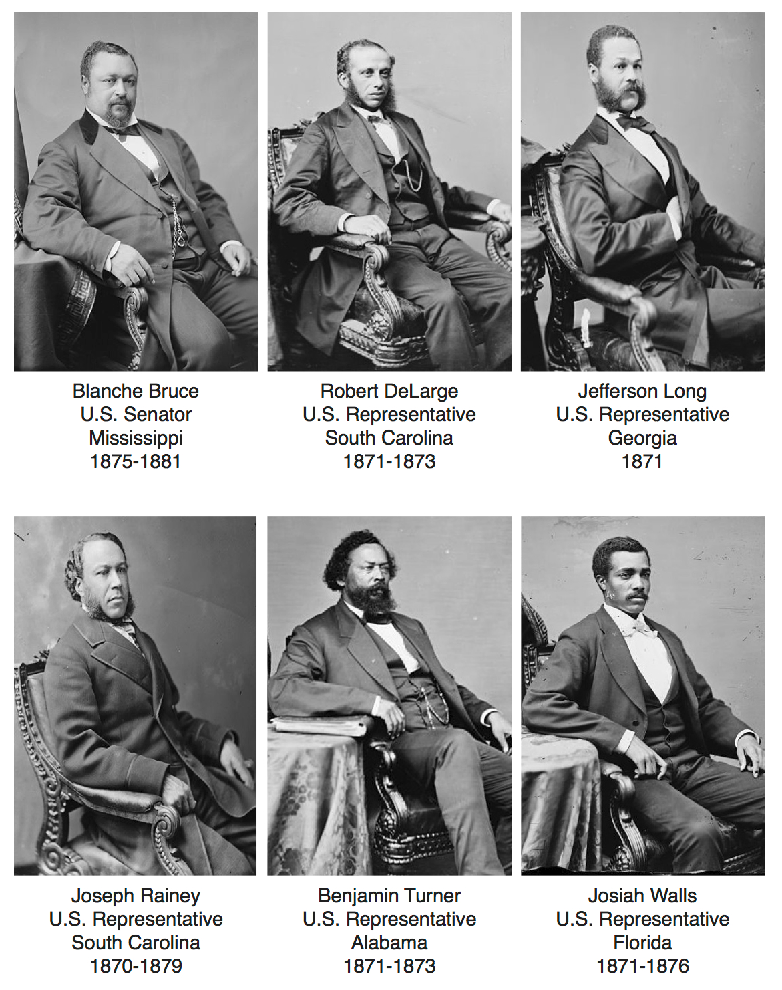

Name: __________________________ Period: ____ Date: _________

Questions to Answer

Document A: The Reconstruction Amendments
1. When were the 13th, 14th and 15th amendments passed?

2. Why do you think they were passed?

3. What rights did they guarantee for American citizens?

Document B: Black Codes
1. When were these Black Codes written? Who do you think wrote these laws?

2. List three things that freed men and women were NOT allowed to do according to the
Black Codes.

3. Why would white Southerners pass laws that controlled the movement of African
Americans? (What do you think would happen if African Americans left the South in huge numbers?)

4. How do these laws help you to understand what life was like in Louisiana and other
Southern states after the Civil War?

Document C: Henry Adams’s Statement
1. Who wrote this document?

2. Why do you think it was written?

3. According to Adams, what was life like for freed men and women after the Civil War?

4. Do you trust the account in this document? Why or why not?

Document D: Education
1. Why do you think education was important to former slaves during Reconstruction?

2. How does this description of life for freedmen compare to Henry Adams’s statement?

Document E: African American Political Representation
1. List some observations about the black men pictured who were elected to Congress.

2. What are some assumptions you can make based on those observations?

ORGANIZING THE EVIDENCE
Use this space to write your main points and the main points made by the other side.
African Americans WERE free during Reconstruction: List the 4 main points/evidence that support this side.
1) From Document _____:

2) From Document _____:

3) From Document _____:

4) From Document _____:

African Americans were NOT free during Reconstruction: List the 4 main points/evidence that support this side.
1) From Document _____:
2) From Document _____:
3) From Document _____:
4) From Document _____:

