Tunisia signs in new constitution
Significant advances for women are among a catalogue of new rights for citizens, in what is being widely received as the most progressive constitution in the Arab world
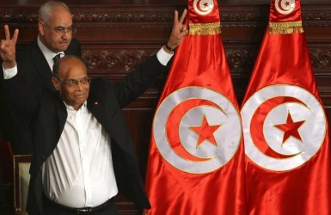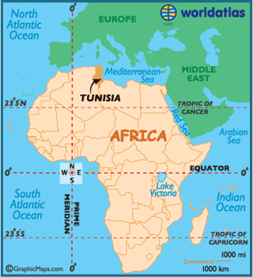
Tunisian President Moncef Marzouki flashes the victory Tunisia is a small country located between Algeria
sign after approving the country’s new constitution. and Libya in northern Africa.

March 5, 2014

Three years after Tunisia’s Jasmine Revolution toppled President Zine El Abidine Ben Ali’s regime and triggered the Arab spring, the country’s lawmakers have signed off on a new constitution.
The document, approved by an overwhelming majority, is the most progressive foundational law of any Arab state, guaranteeing Tunisians’ rights to freedom of speech, to healthcare, to a living wage, to a clean environment, and to freedom from discrimination.
The law also extends significant new rights to women, including protections from violence, the right to marry and divorce freely, and the right to work on the same terms as men.
Perhaps most impressive: at a time when other Arab nations are mired in religious factionalism, Tunisia’s Islamist and secular groups sought to overcome their differences, crafting a document that both asserts Tunisia’s Islamic status and enshrines citizens’ rights to worship and to discuss religious matters freely.
“By adopting the constitution, Tunisia celebrated a triple victory – over dictatorship, over terrorism … and over our own divisions,” said President Moncef Marzouki. His sentiments were echoed by many world leaders, with French president François Hollande saying the constitution affirmed “that Islam is completely in line with democracy,” and should “serve as an example and a reference point for a lot of other countries.”
The Tunisian people, too, expressed excitement about the constitution’s passage. “It is the first time we have been so united since the revolution,” Asma Habaib, a young bank worker, told reporters. “It is like another revolution.”
“The law extends significant new rights to women, including protections from violence and the right to marry and divorce freely.”
Tunisia’s government remains split between religious and secular factions, with Islamist majority party Ennahda pressured in January into ceding control to a caretaker government ahead of a general election later this year. The tension has sometimes spilt over into violence, including political assassinations, but equally clear, observers say, is the rivals’ mutual determination to forge a viable republic.
That made the constitutional assembly a “positively crazy, fantastic environment,” with members coming together to strike deals and keep the process moving forward, secular politician Noomane Fehri told the New York Times.
“We did it in a very innovative, democratic way,” Fehri added. “I dream that kids who are 15 will look back when they are 60 and say, ‘Those guys put us on the right track.’”
The constitution’s framers deserve praise for including “an almost complete list” of protected rights consistent with international standards, Amna Guellali, the head of Human Rights Watch’s Tunisia office, told Positive News.
Crucially, the constitution also establishes the mechanisms – including a new constitutional court and an independent judiciary – needed to enforce those rights.
Still, there are some missing pieces, Guellali said. The constitution failed to ban the death penalty, and is also ambiguous about whether the rights it describes apply to everyone in Tunisia, or only to citizens.
Overall, however, the constitution was a “great achievement,” proving to both sides that compromise was possible, Ginsburg said. The key now is to build political institutions capable of turning that potential into a lasting reality.
“Going forward in a way that makes democracy sustainable is going to be a challenge,” Ginsburg said. “But if there’s any country in the region that can do it, it’s Tunisia.”
-------------------------------------------------------------------------------------------------------------------------------------------
*Tonight’s Homework assignment: Identify and describe 3-4 things you learned about Africa, or in this case Tunisia, from this article. Think about your perceptions of Africa before you read this article, perceptions that other students shared in class during today’s discussion, and how those perceptions may have been affirmed (supported) or denied (not supported) by evidence from this article.

